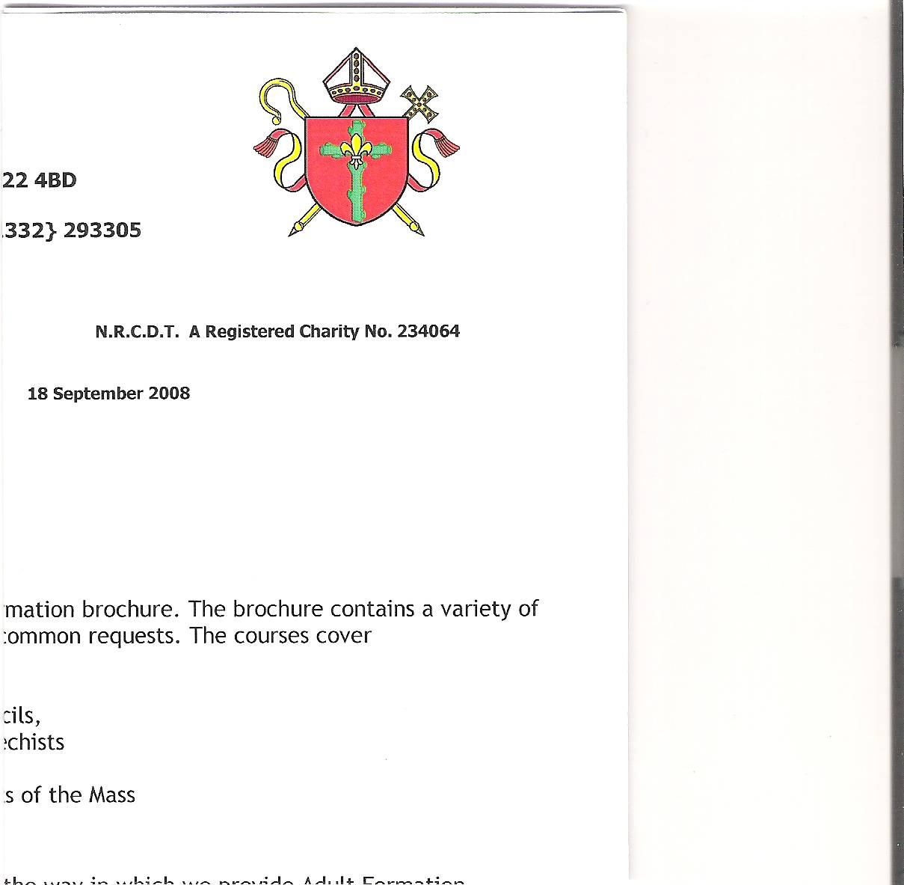

**Holy Cross Parish**

**Hucknall**

**HOLY CROSS PARISH PASTORAL COUNCIL MEETING**

**2nd July 2025**

**ATTENDEES: APOLOGIES**

Father Richard -President Lauren Whitehouse

Simon Clunie - Chair Bodwell Mendy

Vivien Flynn – Minutes

Bill Flynn

Lucas Ortega

Jackie Ortega

Chris Wisniewski

Sue Hanson

Alex Ademiju

**WELCOME AND APOLOGIES**

Following the opening prayer by Simon, he welcomed everyone to the meeting. Apologies received were noted.

**REVIEW OF MINUTES OF LAST MEETING 8th April 2025**

The Minutes were approved as a correct interpretation of the meeting held on 8th April 2025.

**MATTERS ARISING**

**Presbytery Agents**

Simon expressed thanks to Sue and Viv for their efforts in securing the change of agent for the presbytery. The new agents, Bairstow eves are based in Hucknall and have already inspected the premises and submitted their recommendations for positive changes. The previous agents, Spencer Birch prepared a tenancy agreement, none of which was beneficial to Holy Cross. The garden is very overgrown and neglected. Bairstow eves suggested we should arrange for the conifers in the back garden and the trees which are encroaching on the path at the front of the premises be cut back. Once this has been done they will ensure the new tenancy agreement makes it the responsibility of the tenants to maintain. The current rental is way too low for the size and position of the property and they have recommended it be increased to a minimum of £1400 per month. There are 4 adults living in the premises, two of which are not in the current agreement. The new agents will ensure that all four working tenants sign the new agreement.

The official report will be submitted in due course.

**Finance Update**

Lucas circulated a copy of the end of year accounts report and informed the council that we are currently spending more than we are bringing in. It was suggested that a further push on advertising Standing Order payments and Gift Aided contributions be actioned as soon as possible. Taxpayers utilising the gift aid scheme only have to complete and submit a form. This will not affect their tax or their tax code. The government will add a further 25p per £1 donated, which will be claimed by the parish office each quarter.

**Action point:** Lucas will speak to the congregation during Mass on Sunday 6th July and will distribute application forms at the back of church at the end of Mass.

**Health and Safety**

New Fire Exit: The quotation for providing a fire exit using one of the confessionals has been rejected due to the cost of £42,228. We have been informed that we have to have a partition wall by the staircase leading to the choir loft at a cost of a more affordable £2000. Father Richard suggested that we may be able to change this in the future when funds permit. Vaughan has expressed his disappointment at this decision and has written to the chair of the parish council, a copy of which is below. It was also suggested that we should have a ramp at the front of church and an evacuation every six months to comply with fire regulations. Three fire wardens have been appointed and have participated in training.

Good morning Simon,

Thank you for your invite for today's P.P.C.  meeting tonight.  Sadly, yet again I have been omitted from the initial invite in early June, sent on behalf of Father Richard from the parish office.

I do not consider it is your fault, that lies with the office and their distribution list.  I have taken up this matter with them for the last two years and brought it to the last P.P.C. meeting.

I find this totally unacceptable and I therefore resign with immediate effect from the committee, I will not be attending tonight's meeting or any other meetings in the future.

If we are running a P.P.C. that is supposed to be open to parishioners to attend, why was it not published in the newsletter a few weeks before it happened, along with a mention from the pulpit.

On the matter of the proposed partition in our parish porch, I was horrified you mentioned the new budget cost of £40k, when the original budget of £15k was set by the Diocese Building Officer.

I agree with you the office/Diocese do not want the alternative to happen, sadly when our P.P.C. voted to go with it, as they did not want the partition in the porch.

One other thing I forgot to mention to you, I hope they understand that there will be no heat in the entrance hall where they are installing the partition and no heat in the second confessional.

I would appreciate if you would read this out at tonight's meeting, I wish everyone on the Parish Council all the very best for the future

God Bless

Vaughan Gallagher

The Chair and all in attendance expressed their thanks to Vaughan for all his hard work and expertise on behalf of Holy Cross Church.

**Action point:** The parish office to instruct their preferred building company to carry out the partition work.

**Safeguarding**

A DBS update is currently being carried out.

**Action point:** All concerned to complete the required forms.

**Fundraising**

The events group Summer BBQ raised an impressive £1335.00 towards the heating fund. Thanks were expressed to all concerned with the organisation and for those who supported this event.

Dates for the Autumn Bazaar were suggested and are to be confirmed.

A carol concert before Christmas was also included in the suggestions for future events and will include the participation of other communities within Holy Cross and will include a raffle.

**Action point:** Proceed with plans for future fundraising events.

**Parish Merger**

The Diocese has confirmed that Holy Cross Hucknall is to merge with Our Lady’s Bulwell by April 2026. A Parish Merge Committee has been set up consisting of Pauline Lynch - Chair, Simon Clunie, Lucas Ortega, Olimpia Blaj, Bodwell Mendy, Deacon Martin and Bridget Doyle and Onosi Otoakhia from Our Lady's so there will be members from each church as representatives. A photograph of the committee is available at the back of church. There will be one Pastoral Parish Council and one Finance Committee with representatives from both churches. The current PPC will be disbanded by Father Richard and a new constitution will be presented. Consultation documents have been circulated and a request for completed forms to be submitted no later than 7th July 2025. These will be presented to the various councils for approval before the merger can go ahead.

**AOB**

Sue Hanson verbally submitted her resignation from the PPC with immediate effect.

**Action point:** None required.

**Date of next meeting**

The date of the next meeting is to be confirmed.

**Concluding Prayer**

Father said the concluding prayer and the meeting closed at 8.05pm.